COMMUNITY AND SPECIAL SCHOOLS: A JOURNEY OF INCLUSION

A COMMUNITY CONNECT PROJECT REPORT
Submitted by
AFEEF AHEMD SHAIK
(RA2311026050166)
In Partial Fulfillment of the Requirements for the Degree of
BACHELOR OF TECHNOLOGY
in

COMPUTER SCIENCE AND ENGINEERING WITH SPECIALIZATION IN ARTIFICIAL INTELLIGENCE AND MACHINE LEARNING

SCHOOL OF COMPUTING FACULTY OF ENGINEERING AND TECHNOLOGY SRM INSTITUTE OF SCIENCE AND TECHNOLOGY TIRUCHIRAPPALLI – 621105
NOVEMBER 2025


TIRUCHIRAPPALLI
SRM INSTITUTE OF SCIENCE AND TECHNOLOGY
TIRUCHIRAPPALLI
COLLEGE OF ENGINEERING AND TECHNOLOGY

BONAFIDE CERTIFICATE

Certified as the bonafide record of work done by AFEEF AHMED SHAIK (RA2311026050166) of 5TH SEMESTER/3RD YEAR, B.Tech. COMPUTER SCIENCE AND ENGINEERING WITH SPECIALISATION IN
ARTIFICIAL INTELLIGENCE AND MACHINE LEARNING Programme in the project-based course 21GNP301L, Community Connect at SRM Institute of Science and Technology, Tiruchirappalli during the Academic Year 2024- 2025.

Faculty In-charge Head of the Department

Submitted for the End Semester Examination held on .

Examiner 1 Examiner 2

TABLE OF CONTENTS

CHAPTER NO. | TITLE | PAGE NO.
 | PROBLEM STATEMENT | 4
 | LIST OF FIGURES | 7
 | LIST OF ABBREVIATIONS | 8
1 | INTRODUCTION | 9
 | - 1.1 Introduction | 9
 | - 1.2 Level of Innovation | 10
 | - 1.2.1. Conceptual Novelty | 10
 | - 1.2.2. User-Centered Design | 11
 | - 1.2.3. Programmatic Integration | 11
 | - 1.2.4. Measurable Impact and Evidence | 12
 | - 1.2.5 Scalability and Replicability | 12
 | - 1.2.6 Risk Management and Adaptability | 12
 | - 1.3 Community Work and the NGO | 12
 | - 1.4 Milestones and Timeline | 13
2 | DESIGN AND DEVELOPMENT | 16
 | - 2.1. TECHNICAL IMPLEMENTATION | 16
 | - 2.2. DELIVERABLES | 20
 | - 2.3. BUDGET | 22
 | - 2.4. IMPACT ASSESSMENT PLAN | 23
3 | CONCLUSION AND FUTURE WORK | 25
 | - CONCLUSION | 25
 | - FUTURE WORK | 25
4 | APPENDICES AND REFERENCES | 27
 | - APPENDICES | 27
 | - REFERENCES | 32

LIST OF FIGURES

FIGURE NO. | TITLE | PAGE NO.
0 | Gantt Chart of the proposed timeline | 15
1 | Billing-App Frontend | 17
2 | Admin Panel of Billing-App | 17
3 | Code of the Sonta Dabba Maa Navam Lokam website | 18
4 | Design of the Wassan Foundation Website | 18
5 | Design of Maa Nava Lokam Website | 19
6 | Products Page in Maa Nava Lokam | 19
7 | Code of Wasssan Foundation website | 20
8 | Code of Wasssan Foundation website | 20
9 | Picture of the office work. | 21
10 | Picture of on-field work | 22

LIST OF ABBREVIATIONS

API |  | Application Programming Interface
CSV |  | Comma Separated Values
GIS |  | Geographic Information System
GPS |  | Global Positioning System
IoT |  | Internet of Things
NGO |  | Non-Governmental Organization
PNG |  | Portable Network Graphics
SDG |  | Sustainable Development Goals

PROBLEM STATEMENT

Identified Challenges and Problem Statement:
Rural agricultural communities and NGOs such as the Wassan Foundation face multiple critical challenges that hinder efficient resource management and limit meaningful community engagement. Based on fieldwork observations and stakeholder surveys, the following key issues have been identified:

Manual Bill Processing and Record Keeping
- The current financial workflow depends heavily on manual data entry and paper-based processes.
- Monthly financial reports are created by manually reviewing individual bills, entering data into Excel sheets, and then pasting scanned copies of bills into Word documents for record-keeping and audits.
- This approach is time-consuming, prone to errors, and leads to frequent delays in expense tracking, reconciliation, and approval cycles.
- The lack of automation also restricts real-time reporting and financial transparency across departments and projects.

Limited Digital Presence
- The NGO currently has no official website or digital platform to promote its initiatives, showcase completed projects, or advertise upcoming events.
- This absence of an online presence significantly limits outreach to both rural communities and urban supporters interested in sustainable agriculture and natural farming.
- Consequently, opportunities for public engagement, volunteer participation, and donor visibility remain underutilized.

Lack of Accessible Educational Platforms
- Farmers and community members lack accessible digital platforms that deliver information on sustainable agricultural practices and chemical-free living.
- This knowledge gap reduces the adoption of eco-friendly farming methods and inhibits the scaling of successful initiatives.
Time-Consuming Administrative Tasks

- Administrative staff and volunteers spend substantial time on repetitive manual tasks such as data consolidation, report preparation, and documentation.
- These inefficiencies divert attention from core programmatic work and innovation-driven initiatives, leading to frustration among team members and reduced overall productivity.

Inadequate Integration of Data Systems
- The organization relies on disconnected systems for managing finances, operations, and project data.
- This fragmentation makes it difficult to generate comprehensive reports, conduct effective monitoring, and support data-driven decision-making.
- The lack of integrated digital systems further hampers organizational transparency, accountability, and performance tracking.

Impact and Need for Digital Transformation
These challenges directly affect over 500 active users, including NGO staff, administrators, and partner organizations, while indirectly influencing more than 10,000 community members who depend on the Foundation’s agricultural support programs. If left unaddressed, the inefficiencies in financial management, lack of cohesive data systems, and absence of a digital presence will continue to constrain the NGO’s operational effectiveness and community reach.
To address these gaps, developing and deploying integrated digital solutions is essential. A unified system encompassing financial automation, centralized data management, and accessible digital platforms will empower the Wassan Foundation to improve operational efficiency, strengthen transparency, and scale its positive impact across rural and urban communities.

CHAPTER 1 INTRODUCTION

1.1. RELEVANCE TO SDG
My project aligns closely with several Sustainable Development Goals (SDGs). It leverages modern digital solutions to directly address many of the challenges faced by our NGO and the communities we serve. By automating billing and financial reporting processes, the project significantly improves resource allocation and tracking. This transformation allows our organization to operate more efficiently, effectively contributing to SDG 1 (No Poverty), as better resource management ensures that funds are used optimally for poverty alleviation initiatives.

Additionally, by supporting natural farming techniques through accessible digital tools, our platform helps farmers increase food production and improve food security, aligning with SDG 2 (Zero Hunger). Digital platforms can facilitate the dissemination of sustainable farming methods, provide real-time advice, and encourage adoption of eco-friendly practices, thereby making a tangible impact on community nutrition and resilience. One of the core components of our project is educational outreach, which promotes knowledge about chemical-free living and sustainable agricultural practices. This directly influences SDG 3 (Good Health and Well-Being), as communities adopting healthier, chemical-free farming methods decrease exposure to harmful substances, leading to better health outcomes. Furthermore, accessing this information through digital means bridges the knowledge gap, especially in rural areas where traditional extension services may be limited.

Our shift from manual, tedious workflow processes to automated, collaborative, and digital systems reduces the time and effort of staff and volunteers—improving working conditions and productivity. This supports SDG 8 (Decent Work and Economic Growth) by enabling staff to focus on more impactful activities rather than administrative chores. The project also fosters innovation within our NGO by replacing outdated paper-based practices with a scalable, secure, and reliable digital infrastructure, aligning with SDG 9 (Industry, Innovation, and Infrastructure). The project is designed to promote responsible consumption and production (SDG 12). By creating digital communication channels, awareness campaigns, and educational materials, the NGO encourages environmentally responsible behaviors. For instance, promoting sustainable farming methods and resource conservation through our digital platforms helps nurture a culture of responsible consumption among community members and urban supporters alike.

In tandem, our programs and digital tools support SDG 15 (Life on Land) by
advancing environmental conservation initiatives. Natural farming techniques reduce the need for chemical inputs that degrade ecosystems, prevent soil erosion, and promote biodiversity. The digital platforms we develop facilitate monitoring, reporting, and scaling these practices, enabling broader adoption and long-term environmental benefits. Beyond these direct impacts, the project embodies a broader commitment to sustainable development by fostering a digital ecosystem that can sustain iterative improvements, scalability, and resilience. For instance, automated data collection and real-time reporting enable evidence-based decision-making, which improves transparency and accountability—crucial for maintaining donor trust and ensuring compliance with funding requirements.

Furthermore, this initiative contributes to SDG 17 (Partnerships for the Goals). By collaborating with local organizations, research institutions, government agencies, and donor agencies, we create an ecosystem that fosters shared resources, best practices, and policy influence. This multi-stakeholder engagement amplifies the positive impact of our project, enabling broader scaling and replication.

Digital transformation in NGOs is not without its challenges, however. Many organizations face barriers such as limited technical expertise, funding, and infrastructure. Our project aims to overcome these by designing accessible, low-cost solutions that can be easily adopted and maintained, ensuring long-term sustainability. In conclusion, this project not only modernizes our NGO’s operational processes but also acts as a catalyst for broader social, economic, and environmental change aligned with the SDGs. By embedding technology-driven solutions into our organizational fabric, we enable more impactful community programs, foster innovative practices, improve transparency, and contribute to global efforts towards sustainable development. As NGOs increasingly shift toward digital ecosystems, their role as agents of change becomes more effective, scalable, and sustainable, ultimately helping us build a better future for all communities.

LEVEL OF INNOVATION:

: Conceptual Novelty
My project introduces a new and efficient approach to solving long-standing problems in NGO operations, especially in the area of manual billing and data entry. Traditionally, NGOs have relied on slow, paper-based methods that require physically collecting receipts, manually entering data into spreadsheets, and managing paperwork. This old-fashioned process is prone to errors, time-consuming, and hampers transparency. To modernize this, my project uses both client-side and server- side Optical Character Recognition (OCR) technologies. By applying client-side OCR with Tesseract.js, users get instant feedback as their receipt data is extracted immediately when images are uploaded. On the server side, advanced processing
cleans the images and improves accuracy, reducing errors and increasing reliability. The system integrates this data directly with Google Sheets, creating a real-time,
collaborative ledger where staff can access, verify, and manage billing records. Features such as batch uploads, user validation loops, and an admin review panel streamline data corrections and approvals. The modular design with React and Node.js architecture allows for future upgrades without disrupting workflows. This innovation drastically reduces the manual workload, speeds up reimbursements, and enhances transparency, making NGO financial management more accurate and efficient.

User-Centered Design
I placed a strong emphasis on designing the application based on the actual needs and experiences of its users. To achieve this, I conducted multiple surveys and feedback sessions with the staff and volunteers who would be interacting with the system daily. These sessions provided valuable insights into the challenges they face with existing manual billing and data entry processes. Early prototypes of the application were developed and presented to users, allowing them to test features and offer suggestions for improvement. This participatory design approach ensured that the application was not developed in isolation but rather collaboratively with the people who would depend on it. By incorporating continuous feedback throughout the development cycle, I was able to iteratively refine the application, making adjustments that better aligned with their workflows and preferences. This process helped ensure the final solution is intuitive, reduces errors, and fits seamlessly within the organization’s existing operational structure. Ultimately, involving users from the beginning increased adoption rates, user satisfaction, and overall effectiveness of the tool, making it a practical and valuable asset for the NGO.

Programmatic Integration
The digital solution goes beyond just managing finances; it also supports the NGO’s broader program goals by closely linking financial data with activities in education, health, and livelihoods. Each expense entered into the system can be tagged and categorized according to the specific program it supports. This allows the NGO to analyze financial records in relation to their actual program outcomes, helping staff see how funds translate into tangible impact across different sectors. For example, expenses related to education programs can be tracked separately from health-related expenditures, enabling precise budgeting and resource allocation. This programmatic integration not only increases financial transparency but also helps identify which initiatives are most cost-effective and impactful. By connecting costs directly with outcomes, the NGO can make informed decisions about where to invest resources for maximum benefit. Furthermore, this approach enables comprehensive reporting to donors and stakeholders, showing them the direct link between funding and the organization’s achievements. It fosters accountability and strategic planning, ensuring that financial management is a tool for enhancing program effectiveness rather than
just maintaining isolated financial records. This integration of finance and program data ultimately contributes to more efficient use of resources and a greater overall impact in the communities served.

Measurable Impact and Evidence
To measure if the innovation works in practice, I set up a monitoring system with clear indicators like error reduction, processing time, and user satisfaction. Results are reviewed regularly and any issues found feed into the ongoing improvement process. This helps the NGO get concrete evidence of improvement and justify further investment in digital tools.

Scalability and Replicability
The project was designed with scalability in mind, allowing it to be easily extended to additional branches, partner organizations, or community groups with minimal disruption. Adopting a modular architecture ensures that each component—whether it’s the OCR engine, the backend data processing, or the user interface—can be updated, replaced, or expanded independently. This flexibility means new features and improvements can be added without requiring a complete overhaul of the system, making maintenance and scaling more cost-effective and manageable. Comprehensive, clear documentation accompanies the system, detailing setup procedures, configuration options, and usage guidelines. This documentation lowers the entry barrier for new users, making onboarding quicker and smoother. In addition, tailored training materials and guides have been developed, supporting various user skill levels to ensure everyone—from field staff to administrators—can confidently use the system. To facilitate knowledge transfer and broader adoption, a training-of- trainers model has been implemented. This approach empowers selected staff members or community leaders to become local experts who can train others, promoting self-sufficiency, strengthening organizational capacity, and accelerating the spread of the solution across additional sites or organizations. Overall, these design choices together promote wide scalability, sustainability, and adaptability, supporting the NGO’s growth and evolving needs.

Risk Management and Adaptability
The project includes strategies for dealing with uncertainties, such as bugs, changes in requirements, or challenges in the field. I introduced validation checks, flexible handling of file uploads, and continuous user support to ensure the system stays reliable. Regular risk assessment meetings were also held to address potential issues early and keep the innovation process on track.

COMMUNITY WORK AND THE NGO:
The non-profit organization (NGO) requires sustained and reliable funding, strong
local leadership development, and dependable logistics and monitoring systems to effectively scale and sustain the solutions it deploys. These needs are critical for maintaining continuity of operations, ensuring supply chains remain uninterrupted, and providing ongoing support for community engagement activities. The NGO’s relationship with the community is deeply collaborative and embedded; staff, volunteers, and local partners jointly manage activities, prioritize the voices of beneficiaries, and continuously engage to maintain cultural relevance. This partnership ensures that programs are responsive to local needs and grounded in community priorities. Currently, the initiative is in the deployment stage, shifting focus from design to operational resilience. Emphasis is placed on empowering trained community champions to manage day-to-day functions independently. This includes institutionalizing maintenance routines, strengthening supply chains, and ensuring uninterrupted service delivery. Priority needs at this stage include establishing a clear governance framework, rolling out capacity-building programs, and implementing simple feedback mechanisms so beneficiaries can report concerns or suggestions easily.

Financial sustainability is also essential: the NGO aims to diversify income streams to cover recurrent operational costs. Accessible data collection systems enable real- time monitoring, allowing the NGO to adjust activities quickly based on community needs. Formalizing partnerships and documenting operating procedures ensures consistency, while periodic reviews help capture lessons learned and measure outcomes effectively. By investing in local ownership, transparent reporting, and pragmatic monitoring, the organization builds long-term impact and adaptability, maintaining trust and accountability with the communities it supports. These needs address the challenges identified in rural agricultural communities and the NGO’s operational frameworks, including inefficient manual bill processing, lack of digital presence, inaccessible educational platforms, burdensome administrative tasks, and disconnected data systems. Tackling these barriers through integrated digital solutions will improve resource management, transparency, and community engagement, empowering the NGO to expand its positive influence while strengthening its operational effectiveness.

MILESTONES AND TIMELINES:

The timeline for the Wassan Foundation Digital Solutions Project reflects a well- structured and phased approach that guided our work from initial planning to final evaluation. Looking back, the project began with a clear initiation phase, during which I defined the project scope, identified core NGO goals, and led a series of stakeholder meetings. These efforts in early June were vital for capturing broad requirements and establishing alignment with the community’s needs.

In the latter half of June, the focus shifted towards planning and design. With input from both staff and volunteers, I developed the technical solution architecture for our billing app and websites, finalized the UI/UX designs, and obtained approvals for the overall project roadmap and timeline. Setting up the data privacy and security plan at this stage was key for building trust and ensuring compliance before major development began.

By the end of June and into July, our project transitioned into execution, with overlapping development tasks driving real progress. I led development on the bill management app, the dedicated Sonta Dabba Manava Lokam platform, and the foundation’s own website redesign. As technical features came together, we performed API integration and thorough testing to ensure robust functionality and seamless data flows. User acceptance testing followed, giving staff and stakeholders the chance to validate the system in practical scenarios. Midway through July, I conducted remote staff onboarding and training to prepare everyone for their new roles.
The final week was dedicated to deployment, detailed documentation, and impact assessment. I closely monitored system rollout, gathered real-time feedback, and generated comprehensive reports on outcomes and lessons learned. These milestones ensured the solutions were not only delivered, but actively evaluated for effectiveness. Each phase built steadily on the previous, making the project’s overall delivery both systematic and responsive to user and community needs. This thorough sequencing helped maintain momentum, accountability, and adaptability throughout the project.

Phase 1: Initiation
- Defined the project scope
- Identified key NGO goals
- Conducted stakeholder meetings to gather broad requirements and align with community needs
(Took place in early June)

Phase 2: Planning and Design
- Developed technical solution architecture for billing app and websites with inputs from staff and volunteers
- Finalized UI/UX designs
- Obtained approvals for roadmap and timeline
- Established data privacy and security plans to build trust before development
platform, and redesigned the foundation’s official website
- Executed API integration and a comprehensive testing regimen for functionality and data flow
- Conducted user acceptance testing with staff and stakeholders to validate the system
- Provided remote onboarding and training for staff to prepare them for the new systems (Late June through mid-July)

Phase 4: Deployment and Evaluation
- Deployed the solutions to live environments
- Prepared detailed documentation
- Monitored rollout and gathered real-time feedback
- Compiled reports on impact and lessons learned to inform future improvements (Late July)

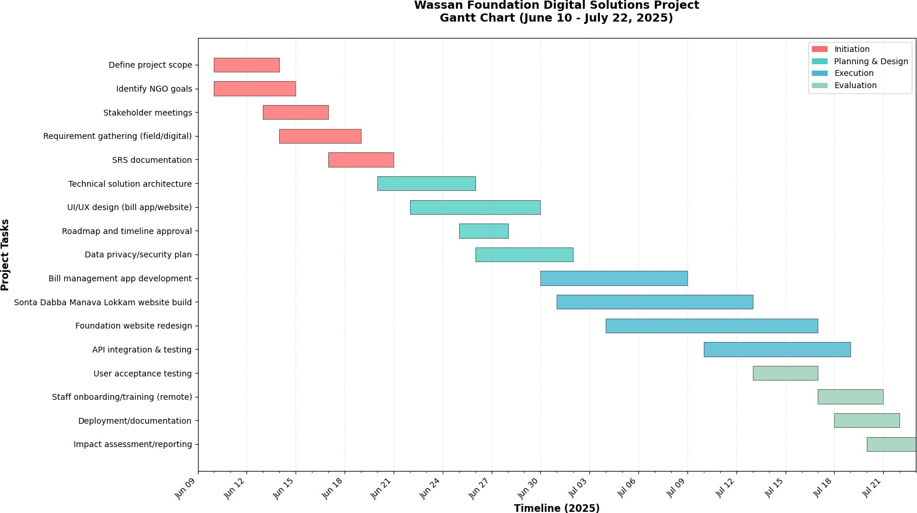
Fig 0. Gantt Chart of the proposed timeline

CHAPTER 2 – DESIGN AND DEVELOPMENT

Technical Approach
For the Wassan Foundation website, I adopted a modular client-server architecture that separates the public-facing frontend, backend API, and admin interface for NGO staff. The system is designed to be resilient and scalable, leveraging CDN-hosted static assets to ensure fast performance, even in rural areas. I implemented a responsive web application with progressive enhancement, service workers for offline support, and accessibility optimizations like image placeholders and lazy loading, which help users with low bandwidth connections. The backend uses REST and GraphQL APIs, with a relational database for structured program data and object storage for media. Security and privacy are prioritized with robust authentication, role-based access, input sanitization, and consent-driven data handling. I built automated CI/CD pipelines for testing and deployment, set up centralized monitoring and audit logs, and provided printed guides, offline admin tools, and thorough documentation to make maintenance practical for NGO teams.

For the Billing Application, I took a hybrid full-stack approach using React and TypeScript for the frontend and Node/Express for the backend. The system integrates client-side OCR for instant feedback and server-side image processing for high accuracy—both are decoupled for easy upgrading. Users upload receipts, see prefilled data, and verify it before submission; the backend cleans up images, runs stronger OCR, and writes structured, deduplicated entries to Google Sheets while storing receipt images in Drive or local files. Administrative workflows are streamlined with batch uploads, an admin review panel, validation loops, and CSV export. Security includes strict credential management, upload validation, and retention policies. The architecture supports asynchronous processing, scalable resource limits, and future extensions like role-based workflows and third-party accounting integrations.

For the Sonta Dabba Manava Lokam website, I followed a similar modular architecture with a responsive frontend, backend APIs, and lightweight admin interface. I focused on rural accessibility with progressive enhancements, offline capabilities, and low-bandwidth support. The backend provides authenticated APIs and secures structured data in relational databases, while media is stored efficiently in document stores. Interoperability is built in through APIs, webhooks, CSV import/export, and integration of SMS and WhatsApp for direct community engagement.

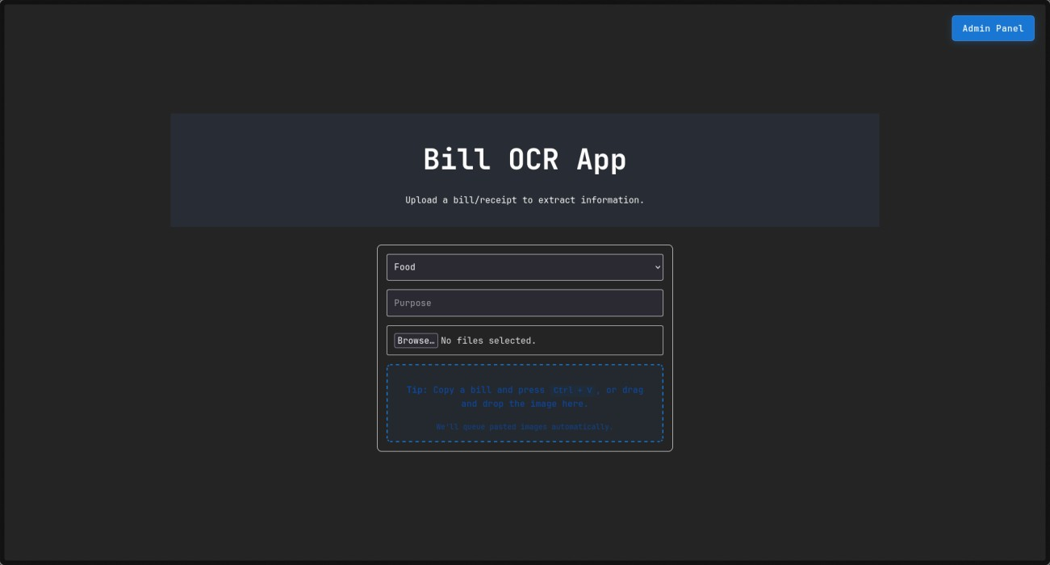
Fig 1. Billing-App Frontend

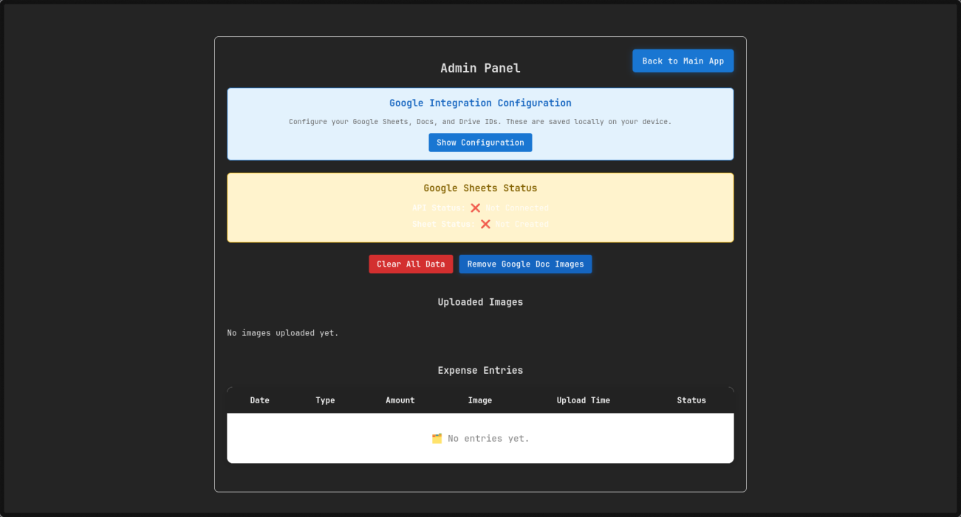
Fig 2. Admin Panel of Billing-App

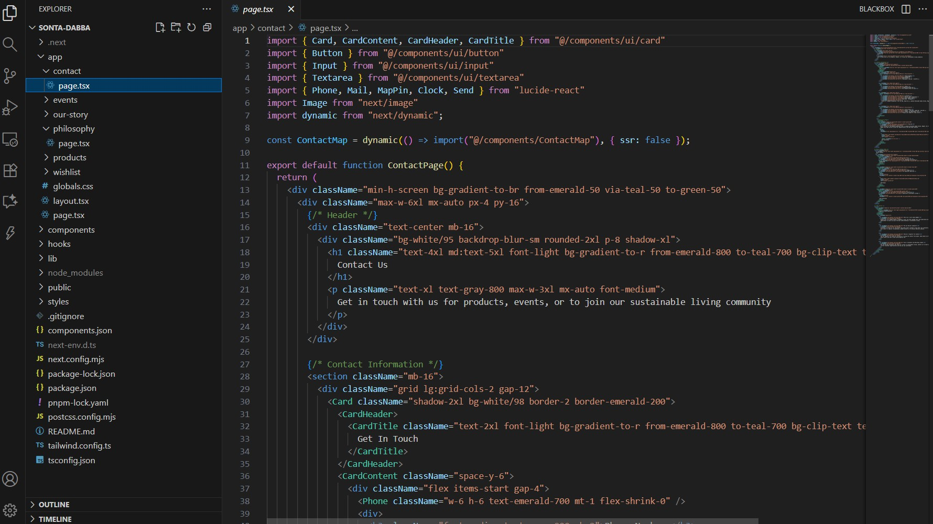
Fig 3. Code of the Sonta Dabba Maa Navam Lokam website

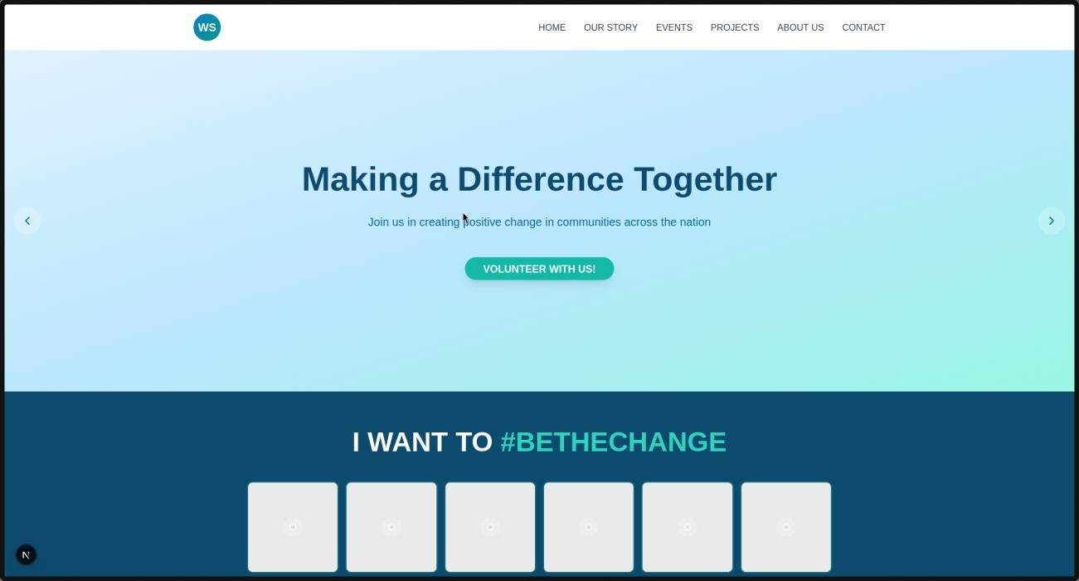
Fig 4. Design of the Wassan Foundation Website

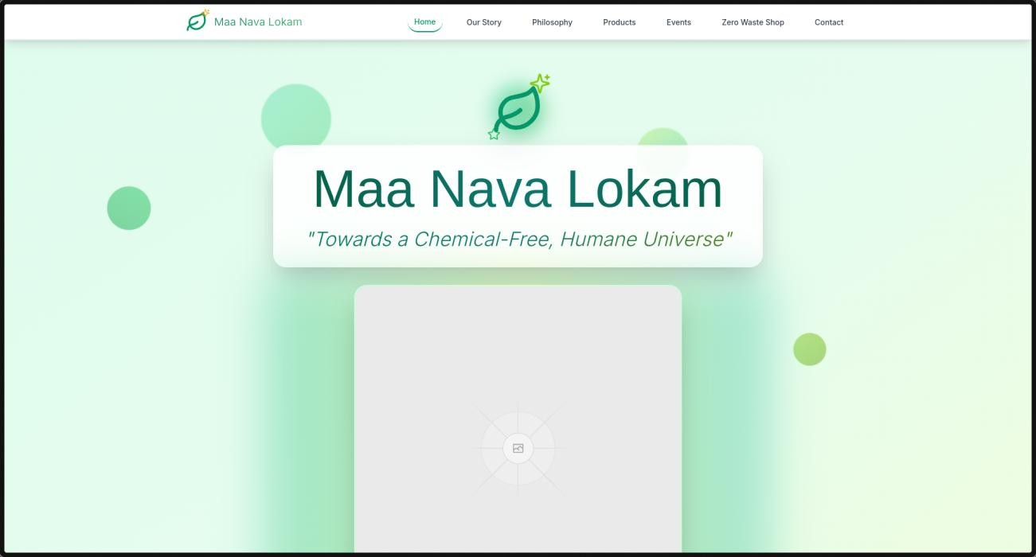
Fig 5. Design of Maa Nava Lokam Website

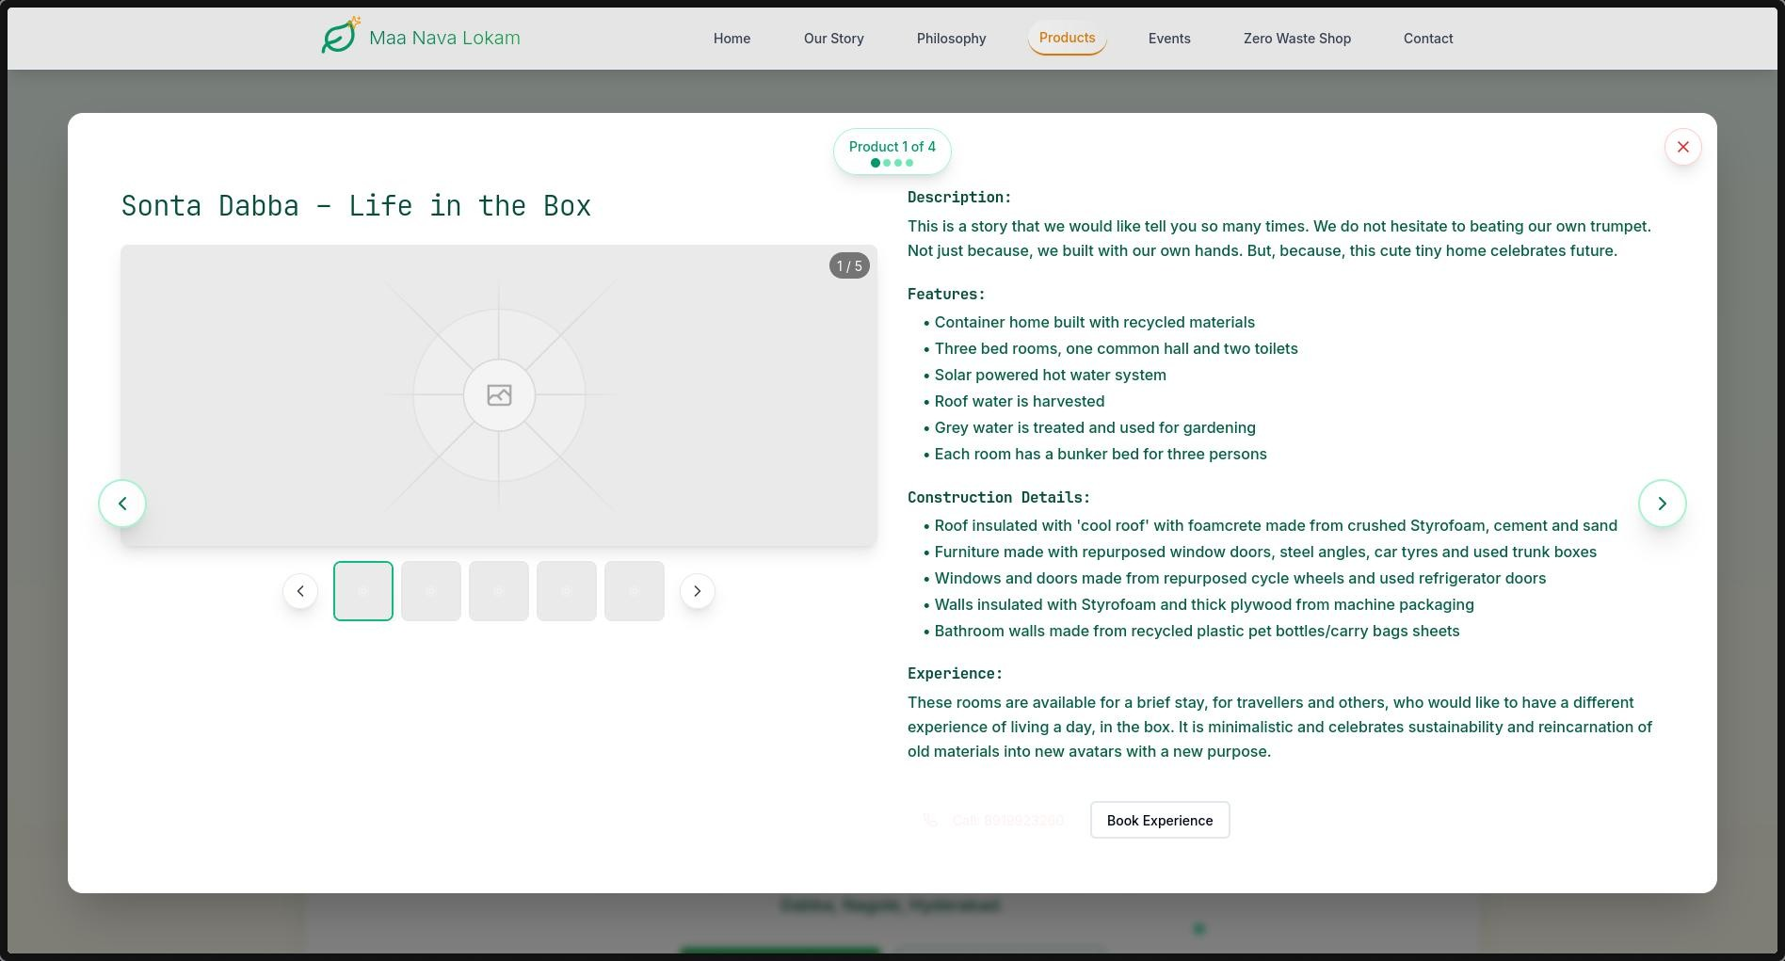
Fig 6. Products Page in Maa Nava Lokam

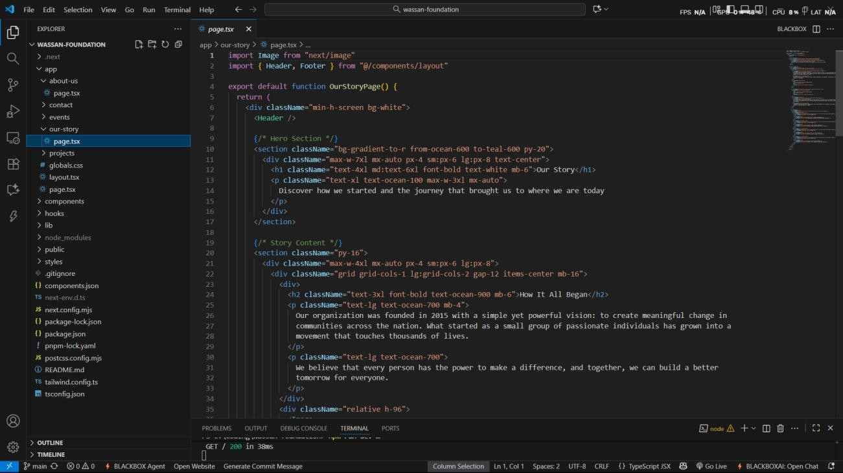
Fig 7. Code of Wasssan Foundation website

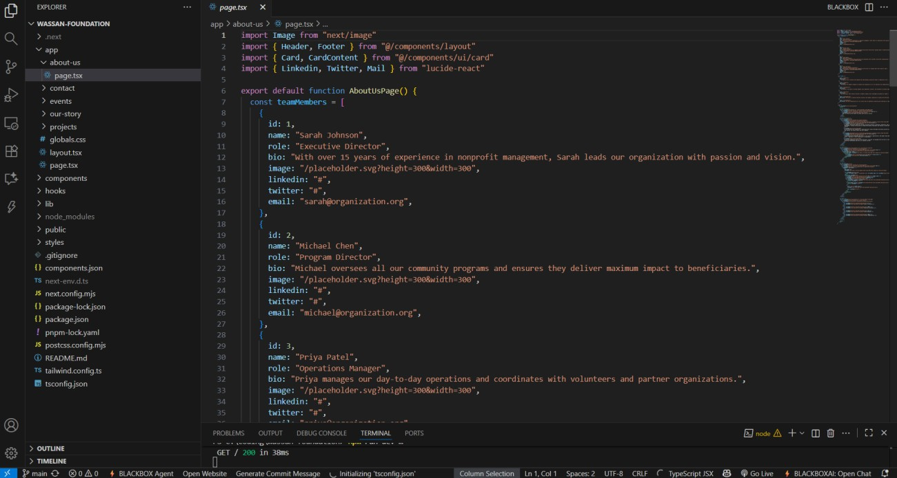
Fig 8. Code of Wassan Foundation Website

DELIVERABLES
Throughout the project, I successfully delivered key outputs aligned with the goals of the Wassan Foundation Digital Solutions initiative. Direct community engagement occurred for one day to collect insights that shaped development. However, all major milestones were achieved through remote collaboration and digital tools, making on-site visits unnecessary. Leadership in this project included overseeing the entire development cycle and leading remote training sessions to build staff capacity for system operation.
The core technical deliverables comprised a fully-functional bill management web application, the Sonta Dabba Manava Lokkam community website, and a proposed design for the Wassan Foundation’s official website. Alongside these, thorough multimedia documentation was prepared, featuring a maintained GitHub repository that hosts all website source code and assets, along with photo documentation of development and engagement activities. The project was formally recognized with a completion certificate, acknowledging successful delivery and impact.
Deliverables in brief:
    - One day of direct community engagement
    - Proactive remote collaboration to meet all project milestones
    - Leadership in development and delivery of digital solutions
    - Remote staff training sessions
    - Bill management web application
    - Sonta Dabba Manava Lokkam website
    - Proposed design for the Wassan Foundation website
    - Comprehensive multimedia documentation
    - GitHub repository with source code
    - Photo documentation of activities
    - Completion certificate acknowledging project delivery

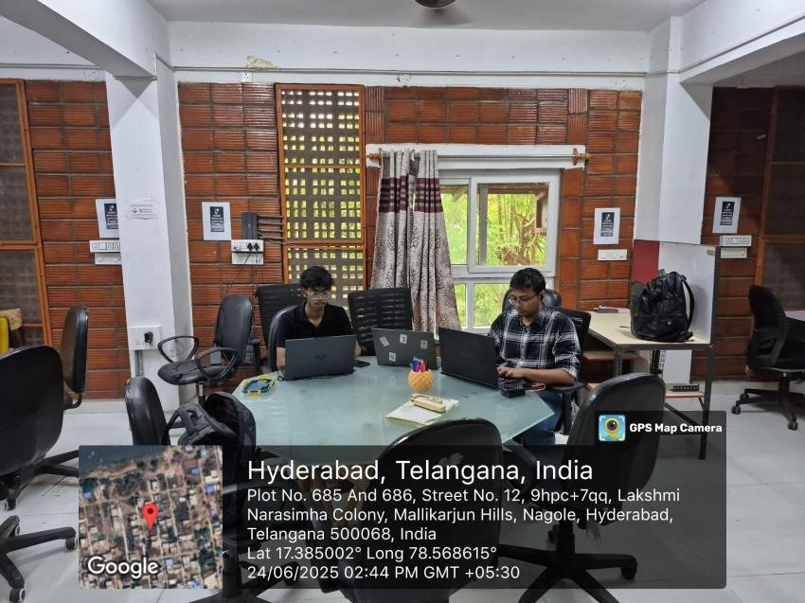
Fig 9. Picture of the office work.

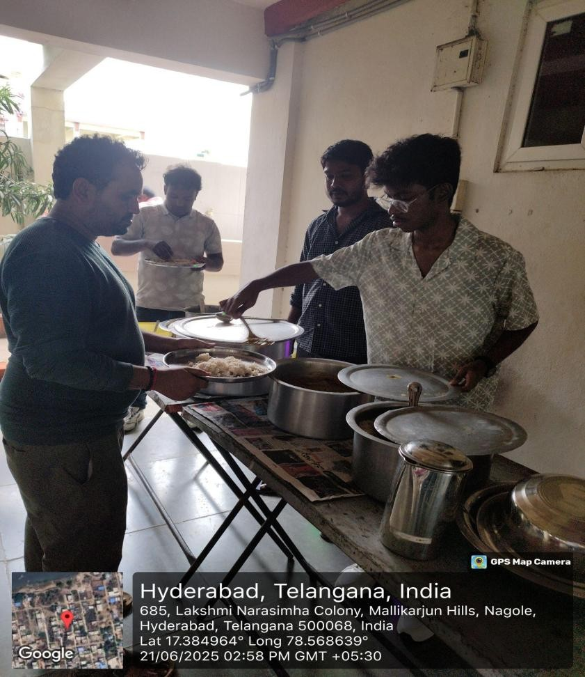
Fig 10. Picture of on-field work.

Budget

Sl.No. | Equipment/Facilities | Qty. | Total (in Rs.) | Justification
1 | Development Tools & Software Licenses | 1 | 25,000 | Web development frameworks, OCR APIs
2 | Cloud Hosting & Domain Services | 1 Year | 20,000 | Website hosting, domain registration
3 | Google Workspace Integration | 1 Year | 15,000 | API access, additional storage
4 | Testing Devices & Equipment | Set | 10,000 | Mobile devices, tablets for testing
5 | Field Visit & Documentation | - | 30,000 | Travel, accommodation, documentation
6 | Training & Support Materials | - | 10,000 | User manuals, training resources
 |  | Total | 1,10,000
Table 1. Budget Table

Impact Assessment Plan
The impact assessment plan for the Wassan Foundation Digital Solutions Project is designed to monitor both immediate and long-term benefits through a carefully constructed framework. A control group will be established, comprising rural agricultural communities and partner organizations that have not yet received the interventions. This control group will allow a clear comparison with the intervention group to measure the direct effects of digital solutions, accounting for external variables and providing reliable data on project outcomes.
In the short term, within one year, the project has already generated significant positive outcomes. These include the reduction of monthly bill processing time from 6 hours to just 1 hour for about 30 active users, such as NGO staff and volunteers, enhancing their productivity and operational efficiency. The project has improved financial transparency, enabling faster and more accurate expense tracking. Educational digital platforms benefit more than 10,000 community members by increasing access to sustainable farming knowledge and promoting chemical-free living, thereby improving overall community health. Furthermore, the Sonta Dabba Manava Lokkam website has demonstrated strong user retention, indicating sustained engagement. Similarly, the Wassan Foundation's website effectively communicates ongoing events and showcases completed projects, fostering trust and involvement from supporters.

The long-term impacts projected within three years target deeper systemic change, including sustainable livelihoods due to increased adoption of eco-friendly farming practices throughout the broader community. There is an expectation of improved health outcomes from reduced chemical usage in agricultural processes. The NGO also aims to achieve financial sustainability through streamlined resource management and workflow optimization. The benefits will extend to tens of thousands, expanding beyond initial users to rural and urban populations alike. Both digital platforms are designed for growth and offer scalable, adaptive engagement tools to maintain strong community connections. Regular data-driven monitoring, incorporating qualitative and quantitative indicators, will inform ongoing adjustments, ensuring the project remains aligned with its sustainability and impact goals.
Key points summarizing the impact assessment:
    - Establishment of a control group for comparative analysis.
    - Reduction of bill processing time from 6 hours to 1 hour for 30 active NGO users.
    - Enhanced financial transparency and efficiency in reporting.
    - Short-term community benefits to over 10,000 individuals through educational platforms.
    - Strong user retention on the Sonta Dabba Manava Lokkam and Wassan Foundation websites.
    - Long-term aims for sustainable livelihoods, improved health, financial sustainability, and broader impact across tens of thousands.

\

CHAPTER 3
CONCLUSION AND FUTURE WORK
  - Conclusion
The digital transformation project implemented for the Wassan Foundation has successfully demonstrated how technology can significantly enhance the operational efficiency and outreach capabilities of non-profit organizations. By automating critical administrative tasks such as bill management and financial tracking, the NGO has been able to reduce administrative overhead and redirect resources toward its core mission of promoting sustainable agriculture and community development. The newly developed digital platforms have also broadened community engagement, making crucial information and educational resources more accessible.
Feedback from NGO staff and beneficiaries indicates improved transparency, streamlined workflows, and a heightened sense of collaboration across diverse stakeholder groups. The redesign of the Wassan Foundation website and the introduction of interactive community portals have not only elevated the NGO’s visibility but also fostered stronger connections with donors, volunteers, and local communities. These improvements contribute to building trust and encouraging greater participation in sustainability initiatives, which are essential for long-term impact.
Looking ahead, the modular and scalable design of the implemented digital solutions provides a robust foundation for future enhancements. Plans for incorporating advanced features such as real-time data analytics, mobile applications, and AI- driven insights will further empower the NGO to respond dynamically to evolving community needs. Additionally, expanding training and capacity-building initiatives will ensure continuous adoption and maximization of technological benefits.
In summary, this project illustrates the transformative potential of integrating digital tools within non-profit operations, ultimately advancing social, environmental, and economic outcomes. The success of Wassan Foundation’s digital transition serves as a replicable model for other NGOs aiming to leverage technology for greater impact and sustainability. Continued investment in digital infrastructure and strategic innovation will be key to meeting future challenges and scaling the foundation’s positive contributions to rural communities.

Future Work
The future of the Wassan Foundation Digital Solutions Project lies in continuous innovation and adaptive scaling to address evolving environmental and socio- economic challenges. To ensure sustained impact, the project plans to establish and strengthen collaborations with government agencies, academic institutions, and private sector partners. These partnerships will create an ecosystem-wide synergy essential for holistic and large-scale sustainable development initiatives. Capacity building remains a key focus, with plans to empower local staff and community
technological inclusivity ensures that the digital transformation remains accessible to all stakeholders, including those in remote and resource-constrained rural areas. This commitment to inclusivity will help bridge the digital divide and foster broader adoption of innovative solutions.

The project also envisions an ongoing evolution that keeps the Foundation relevant and resilient amidst dynamic conditions. By incorporating feedback loops, data- driven decision-making, and integrating emerging technologies, the initiative will maintain agility in its approach. Over time, this will contribute to a broader paradigm shift toward inclusive, sustainable, and technology-enabled rural development. The digital infrastructure will expand beyond administrative automation to actively support climate-resilient agriculture, biodiversity conservation, and livelihood enhancement. Overall, this forward-looking strategy positions the Foundation as a leader in pioneering digital solutions that empower communities and drive long-term ecological and social well-being.
Key future work points:
    - Establish multi-sectoral partnerships for ecosystem synergy
    - Ongoing capacity building and community empowerment
    - Prioritize technological inclusivity for equitable access
    - Implement adaptive scaling and continuous innovation
    - Integrate feedback and data for agile management
    - Expand digital tools to support climate and livelihood goals

CHAPTER 4 - APPENDICES AND REFERENCES

Appendices
Appendix A: Picture of office work
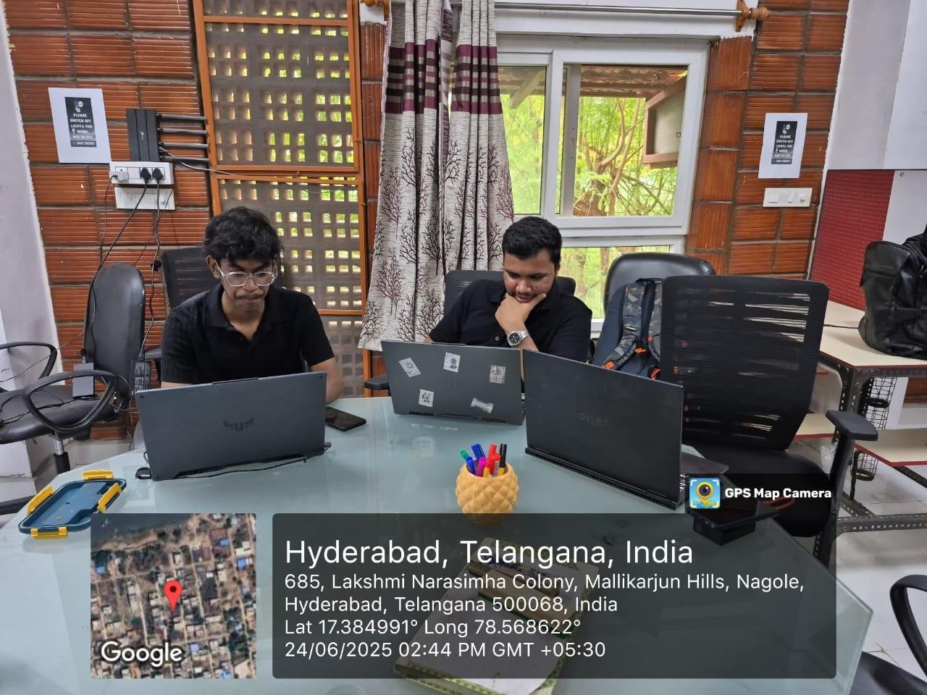

Appendix B: Picture of on-field work


Appendix C: Attendance sheet
Date | Places Visited | No. of community users interacted | Work Carried out
9/6/25 | Wassan, Plot No. 685 and 686, Street No. 12, Lakshmi Narasimha Colony, Mallikarjun Hills, Nagole, Hyderabad, Telangana 500068 | 25 | General volunteering for an event, which showcased different goods from sustainable vendors.
11/6/25 | Wassan, Plot No. 685 and 686, Street No. 12, Lakshmi Narasimha Colony, Mallikarjun Hills, Nagole, Hyderabad, Telangana 500068 | 8 | Meeting and survey to gather information about the needs of the NGO
12/6/25 | Wassan, Plot No. 685 and 686, Street No. 12, Lakshmi Narasimha Colony, Mallikarjun Hills, Nagole, Hyderabad, Telangana 500068 | 9 | Identification of the various technical problems faced by the NGO
13/6/25 | Wassan, Plot No. 685 and 686, Street No. 12, Lakshmi Narasimha Colony, Mallikarjun Hills, Nagole, Hyderabad, Telangana 500068 | 4 | Proposal of inovative technical solutions for the problem faced by them.
14/6/25 | Wassan, Plot No. 685 and 686, Street No. 12, Lakshmi Narasimha Colony, Mallikarjun Hills, Nagole, | 6 | Discussing about further changes needed for the proposed projects.

 | Hyderabad, Telangana 500068
15/6/25 | Wassan, Plot No. 685 and 686, Street No. 12, Lakshmi Narasimha Colony, Mallikarjun Hills, Nagole, Hyderabad, Telangana 500068 | 2 | Start of implementation of the project.
18/6/25 | Remote | 2 | Implementation of the billing app
19/6/25 | Remote | 2 | Implementation of the billing app
20/6/25 | Remote | 2 | Implementation of the billing app
21/6/25 | Remote | 2 | Implementation of the billing app
22/6/25 | Remote | 2 | Implementation of the billing app
25/6/25 | Remote | 2 | Implementation of the billing app
26/6/25 | Remote | 2 | Implementation of the billing app
27/6/25 | Remote | 2 | Implementation of the billing app
28/6/25 | Remote | 2 | Implementation of the billing app
30/6/25 | Remote | 2 | Implementation

 |  |  | of the sonta- dabba maa nava lokkam website
1/7/25 | Remote | 2 | Implementation of the sonta- dabba maa nava lokkam website
2/7/25 | Remote | 2 | Implementation of the sonta- dabba maa nava lokkam website
3/7/25 | Remote | 2 | Implementation of the sonta- dabba maa nava lokkam website
4/7/25 | Remote | 2 | Implementation of the sonta- dabba maa nava lokkam website
7/7/25 | Remote | 2 | Implementation of the sonta- dabba maa nava lokkam website
8/7/25 | Remote | 2 | Implementation of the sonta- dabba maa nava lokkam website
9/7/25 | Remote | 2 | Implementation of the wassan- foundation website
10/7/25 | Remote | 2 | Implementation of the wassan- foundation website
11/7/25 | Remote | 2 | Implementation of the wassan-

 |  |  | foundation website
14/7/25 | Remote | 2 | Implementation of the wassan- foundation website
15/7/25 | Remote | 2 | Implementation of the wassan- foundation website
16/7/25 | Remote | 2 | Implementation of the wassan- foundation website
17/7/25 | Wassan, Plot No. 685 and 686, Street No. 12, Lakshmi Narasimha Colony, Mallikarjun Hills, Nagole, Hyderabad, Telangana 500068 | 25 | Training users on how to use the bill- scanning website
18/7/25 | Wassan, Plot No. 685 and 686, Street No. 12, Lakshmi Narasimha Colony, Mallikarjun Hills, Nagole, Hyderabad, Telangana 500068 | 25 | Training users on how to use the bill- scanning website
21/7/25 | Wassan, Plot No. 685 and 686, Street No. 12, Lakshmi Narasimha Colony, Mallikarjun Hills, Nagole, Hyderabad, Telangana 500068 | 25 | Training users on how to use the bill- scanning website
22/7/25 | Wassan, Plot No. 685 and 686, Street No. 12, | 4 | Final discussion about overall

 | Lakshmi Narasimha |  | impact of
 | Colony, Mallikarjun |  | projects on the
 | Hills, Nagole, |  | betterment of
 | Hyderabad, Telangana |  | the NGO
 | 500068

CERTIFICATE FROM NGO

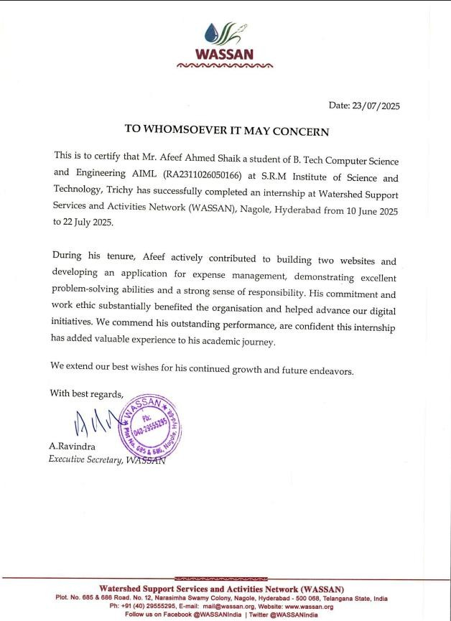

REFERENCES:

    - FAO. (2020). Digital agriculture in action – Selected case studies from India. Food and Agriculture Organization.
    - CGIAR. (2022). Digital agriculture in action: Selected case studies from India. CGIAR Research Program on Policies, Institutions, and Markets.
    - ICT for Change. (2022). The Digital Ecosystem Opportunity for Indian Agriculture.
    - ScienceDirect. (2024). Digital transformation of the agricultural industry: innovations and challenges.
    - Wassan Foundation. (2022). Annual Report 2022-23. Wassan Foundation.
    - JEMI. (2025). Final analysis on digital transformation and its impact. International Journal of Public Resilience and Management.
    - Think20. (2023). Leveraging technology for rural community development.
    - FAO. (2019). Sustainable food and agriculture – A review. Food and Agriculture Organization.
    - World Bank. (2024). Digital Adoption for Inclusive Development.
    - NITI Aayog. (2021). Transforming India: Towards a Digitally Empowered Society. Government of India.

